Sol 1.
(a) Compute the probability that a randomly chosen customer is a high spender.
We use the abbreviations HF,LF,HS, and LS to refer to high frequency, low frequency, high spender, and low spender. Using the total probability theorem,
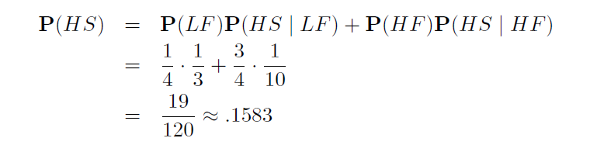
(b) Compute the probability that a randomly chosen customer is a high frequency buyer given that he/she is a low spender. Using Bayes’ rule,
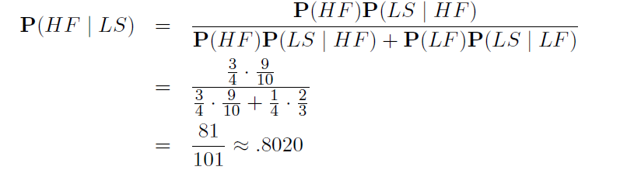
(c ) Compute the probability that a customer purchases a book or a CD.
We use the abbreviations B,C,D for buying a book, CD, or DVD. P(BᴜC) = P(B)+P(C) because a customer can only buy 1 item, and hence B and C are disjoint. Applying the total probability theorem

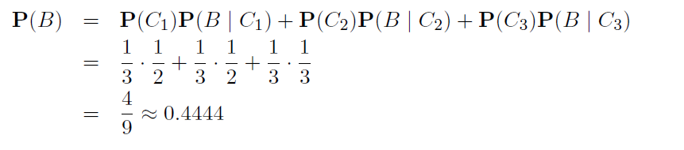

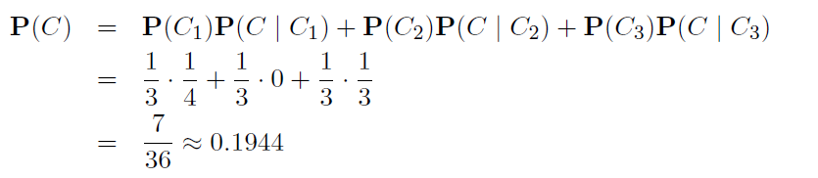

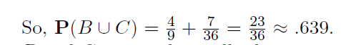
(d) Compute the probability that a customer is in group C2 or C3 given he/she purchased a book.
We use Bayes’ rule.
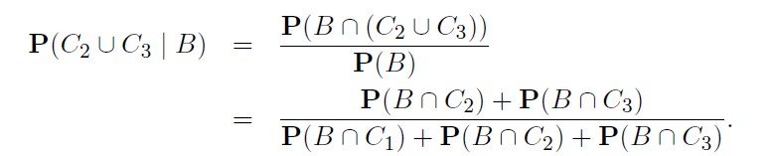

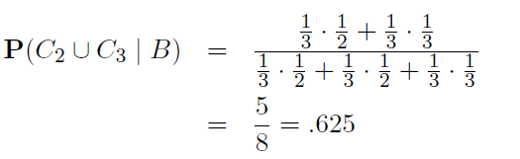

Sol 2
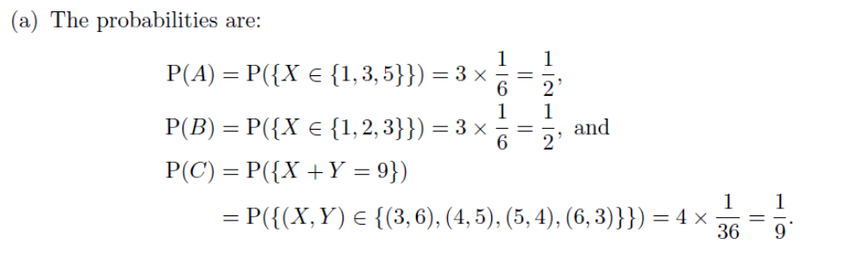

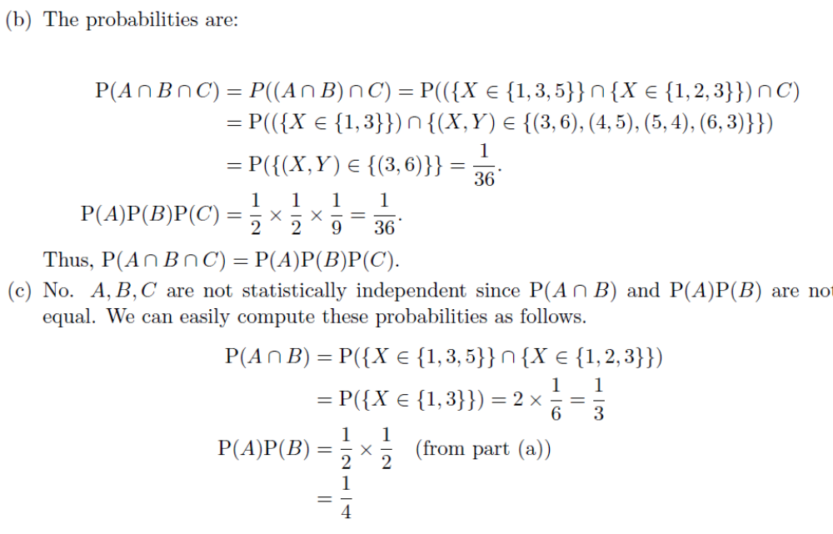

Sol3
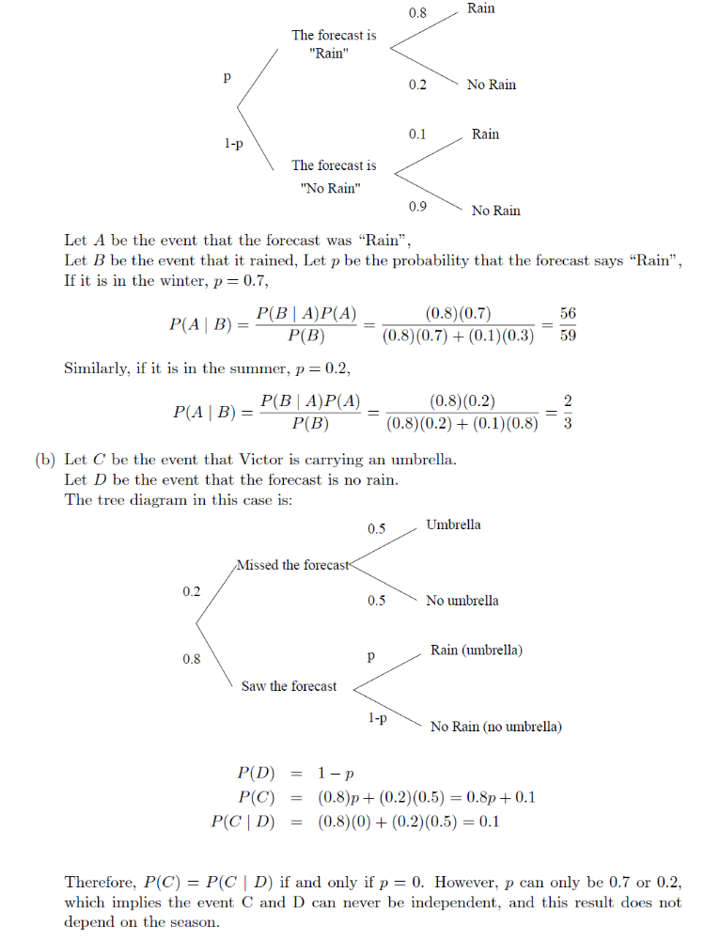

Sol4
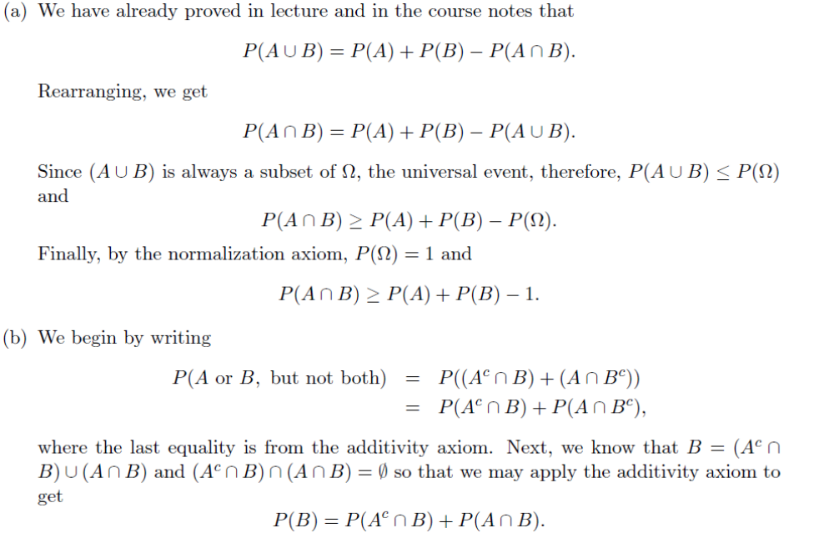

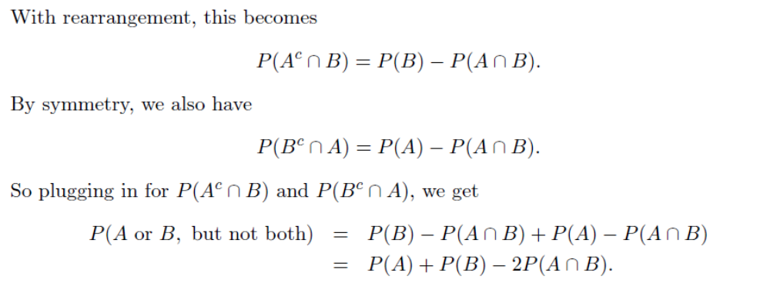

Sol 5
